# **LONDON**

THE CITY, MESEUMS AND MONUMENTS.

# What does it mean when we say that a city is wonderful? Does it only mean that it has wonderful architecture, or that its people, its institutions are interesting?

Its characteristics is that it is very modern and, at the same time, very respectful of traditions and habits.

In London there is the City, with its businessmen wearing bowlers, there are the National Guards in their traditional costumes, there are the colorful markets of Petticoat Lane and of Covent Garden and the bridle paths in Hyde Park.

The City is the commercial and financial center of London. Its heart is Trafalgar Square.

The area of the City is about one square mile and corresponds to the extent of the capital in medieval times.

Famous monuments are the Tower

Bridge, the Houses of Parliament, the Big Ben – one of the largest and most accurate clocks in the world- and the London Tower that is one of the principal tourist attractions in England. Today it is a sort of museum, but it was for a long time one of the chief prisons of the country.

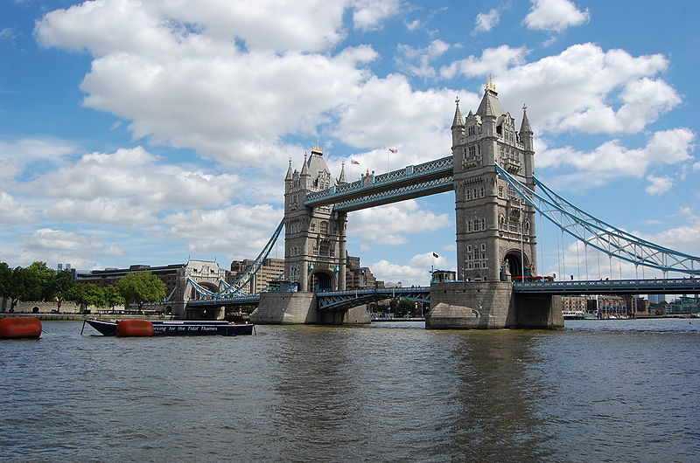

The Tower Bridge.

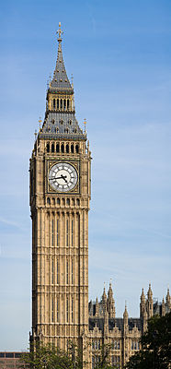

The Big Ben.

The Tate Gallery is an important art museum, and only one of several large and excellent museums in London, among wich the British Museum is probably the most famous. It was established in 1753 and is also the most rich library in England.

Trafalgar Square: is considered the heart of the City of London.

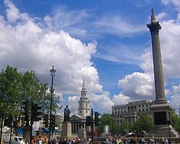

THE TUBE.

The underground railway, called tube, is certainly one of the most modern means of transportation, infact many importat cities have one. The tube is quite amazing; it works with the greatest punctuality and it is very confortable. So vast is London that the underground alone cannot handle all the city traffic: innumerable red double-deker buses are to be seen everywhere. The price of a ticket depends on the length of the ride.

THE THAMES.

By cruising up the Thames, the principal impression is given by the fact that you soon find yourself in very idyllic landscape. You can reach Oxford, passing by Eton with its famous school, Hampton Court and Windsor with its Royal Palace. Cambrige and Oxford are two of the most famous universities in England.

A summer journey, up the river Thames, is something which will remain vivid in your memory.

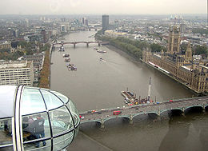

The Thames and the Houses of Parliament